Guide to adding users to your account

To help with account management and fundraising across your organization, you can add up to 200 users to your PayPal account.
When you add a user to your account, you are asked to provide the following information:
- User ID - A unique ID that is 8-16 characters long and contains only letters and numbers. Choose the user ID carefully; once assigned, you cannot change it.
- Password — A combination of 8-20 characters that contains letters, numbers, and special characters. You can change the password, as needed.
- User Access - Select one or more privileges from the list on the page.
To get started, log in to your PayPal account and go to My Profile.
Select the "My settings" tab on the left, and click "Account Access" and then select the “update” button next to Manage Users.
Once in the Manage users section of your account, you'll be able to add and delete users, and edit their access privileges.
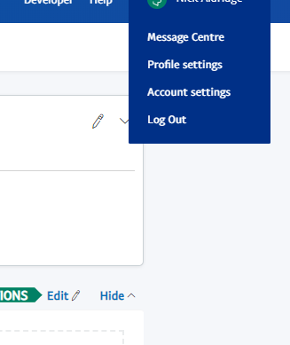
When adding a user to enroll in and manage PayPal Giving Fund, we recommend selecting the " Access Reports” for both the US & IRE privilege listed under Administration to grant them the necessary access. You can add more privileges, as needed.

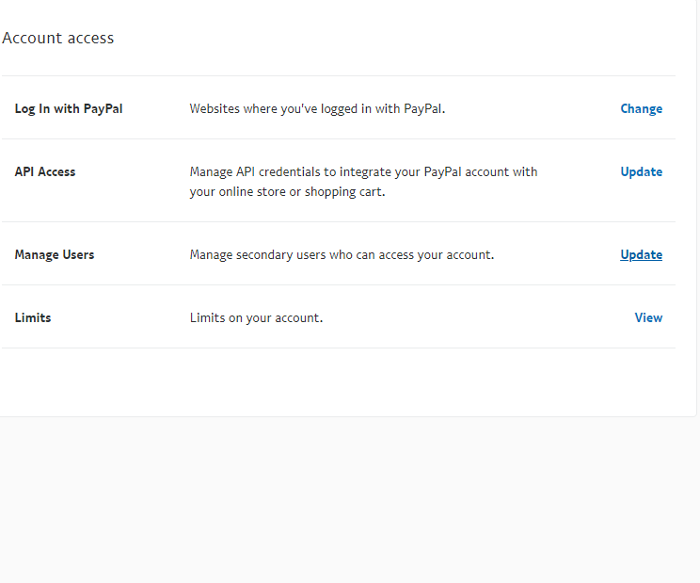
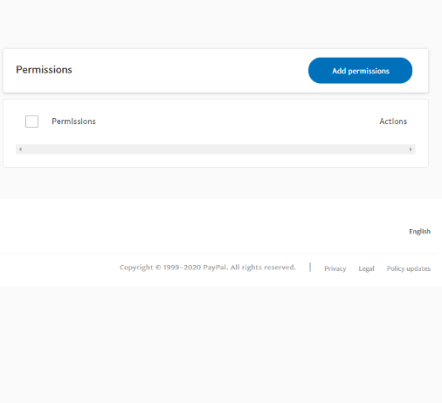
1. Profile and settings 2. My settings > Manage users 3. Administration > View Profile

Copyright 2020 PayPal. All rights reserved.

